**🔶 1. Explain the concept of discriminant functions in pattern classification. How are they used to assign a feature vector to a class? Illustrate with an example.**

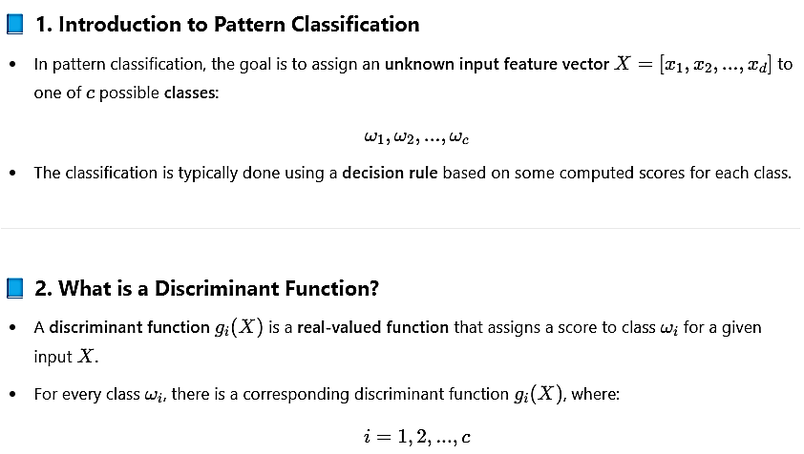

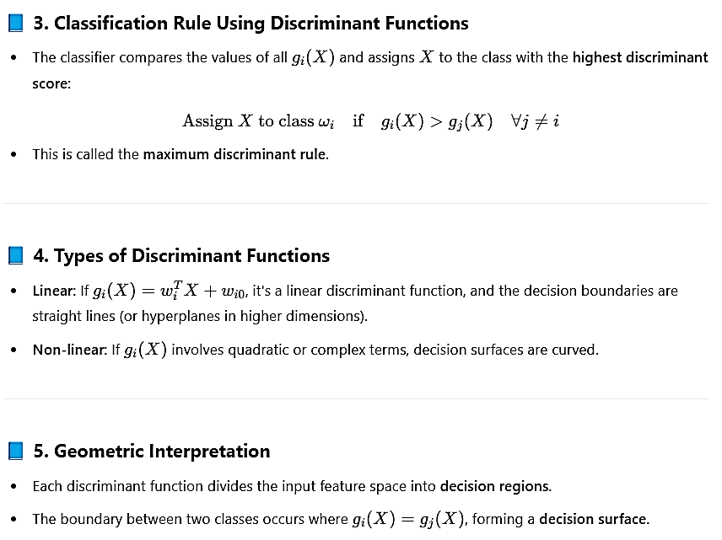

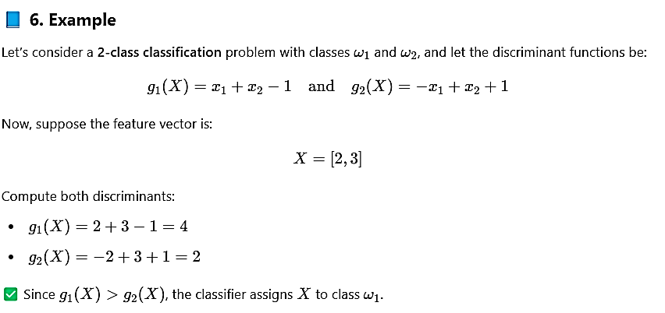

Thus, **discriminant functions are central to classification**, allowing us to compute scores and divide the feature space for decision-making.

**🔶 2. Derive the classification rule using discriminant functions under the Bayesian Decision Theory framework. Show how minimizing conditional risk relates to maximizing a discriminant function.**

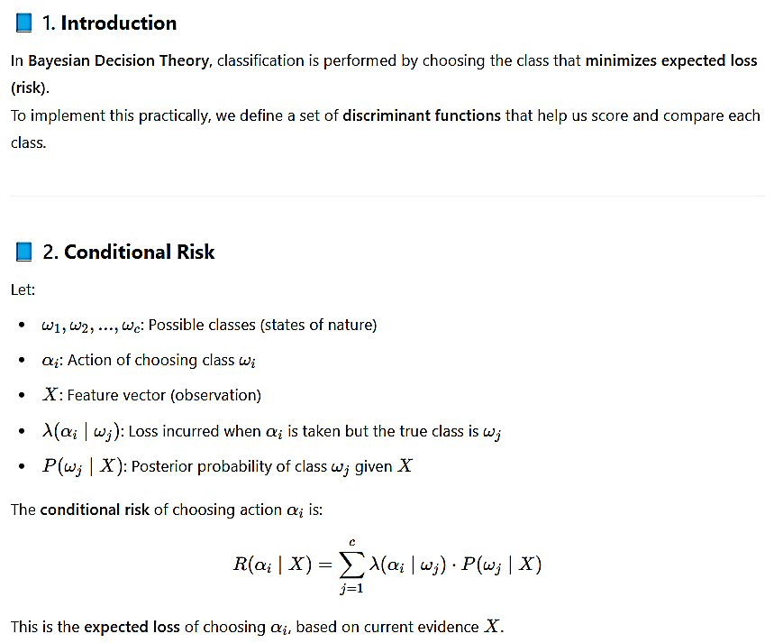

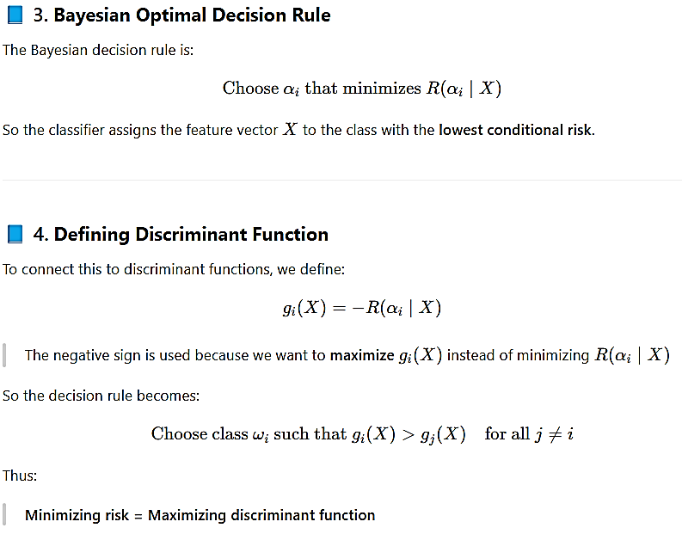

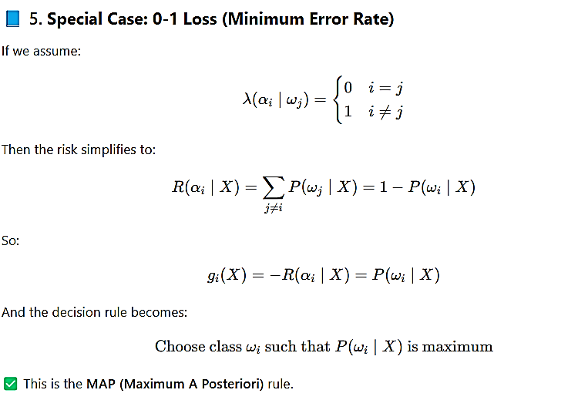

**🔶 3. What is the Minimum Error Rate Classifier? Derive it using 0-1 loss and show how it leads to the MAP (Maximum A Posteriori) rule.**

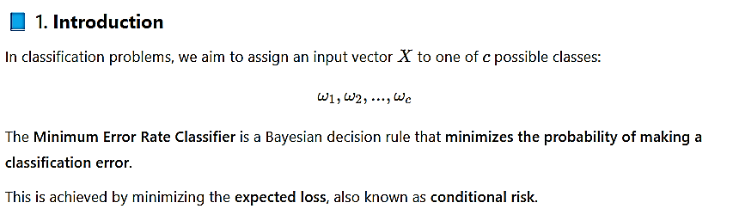

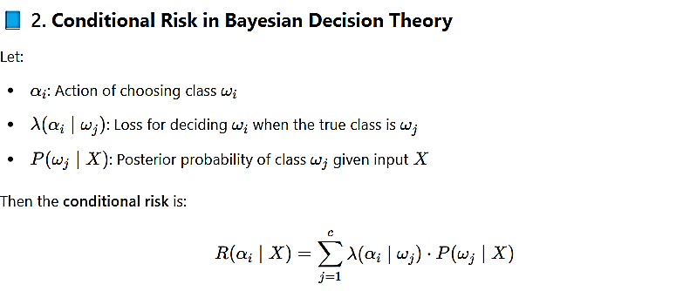

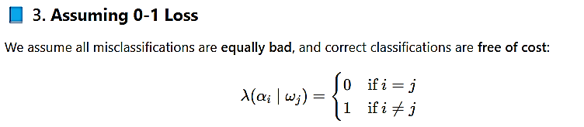

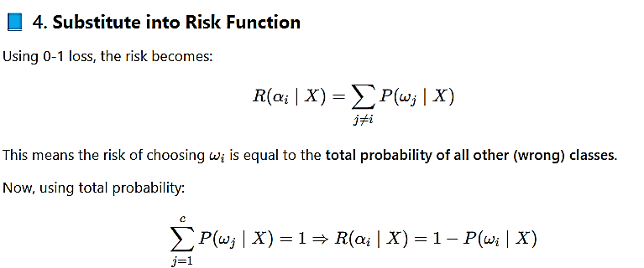

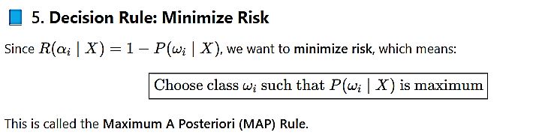

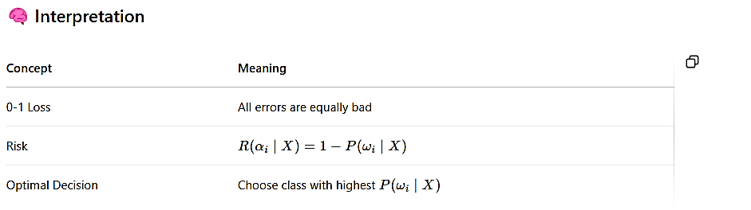

**🔶 4. Discuss the role of posterior probability in decision making. Derive the formula for posterior using Bayes' Theorem and show how it is used as a discriminant function.**

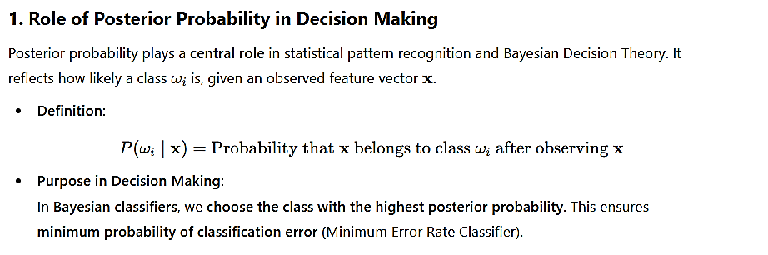

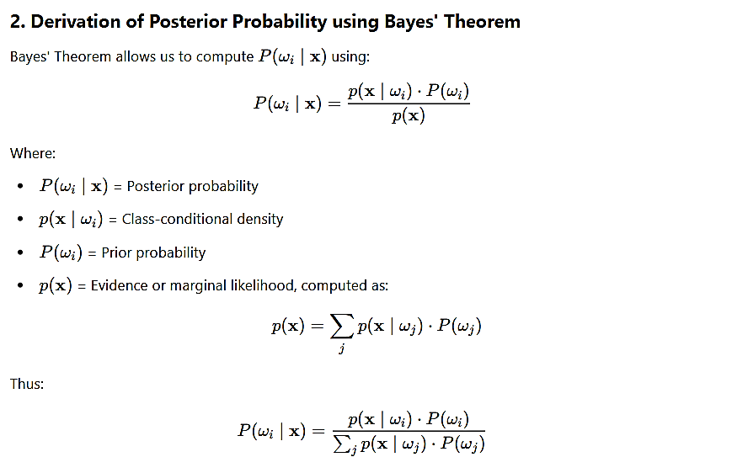

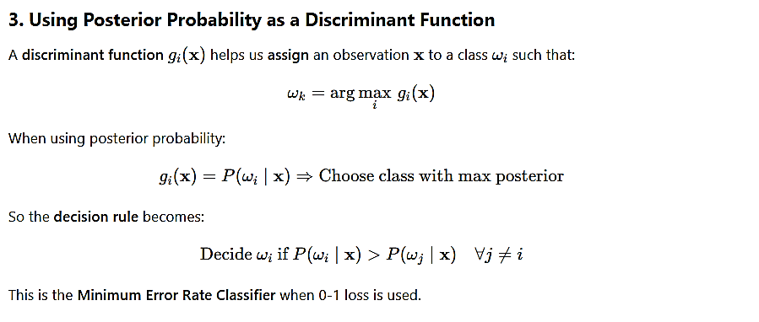

**🔶 5. With the help of mathematical expressions, explain how the feature space is divided into decision regions and how decision boundaries (surfaces) are formed.**

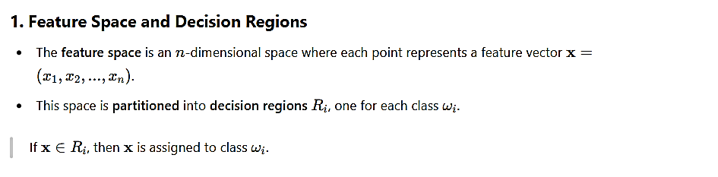

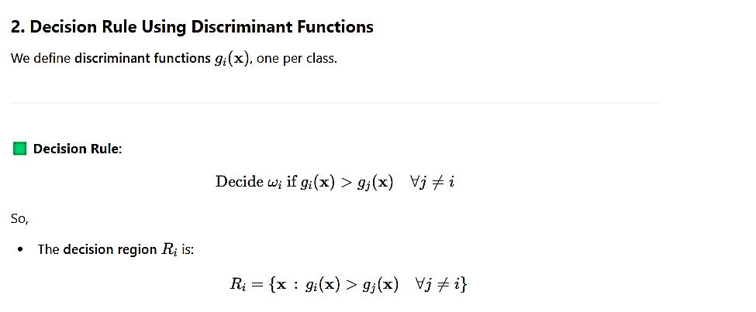

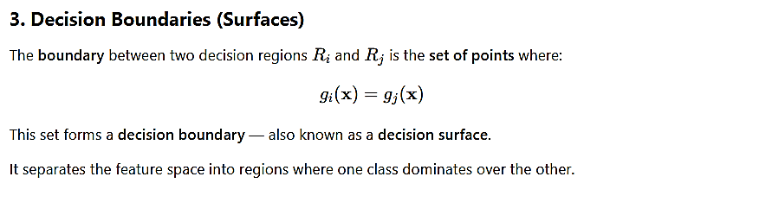

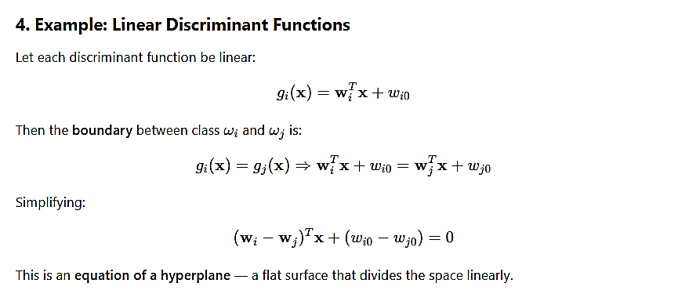

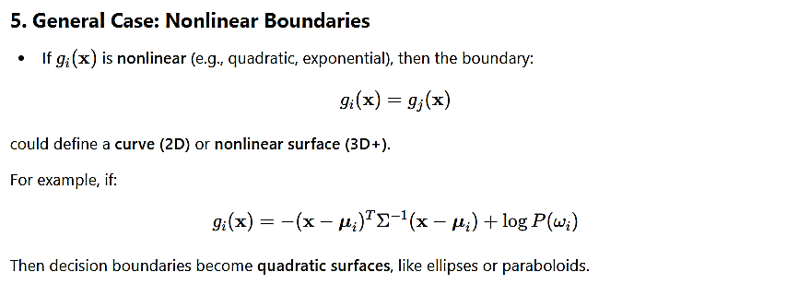

**🔶 6. Show that applying a monotonically increasing function to discriminant functions does not affect the final classification result. Explain this using log-discriminant transformation.**

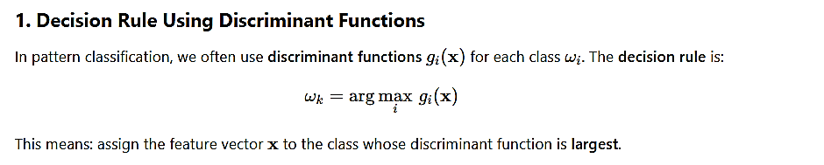

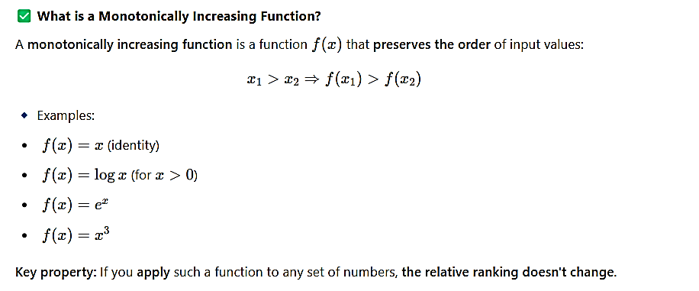

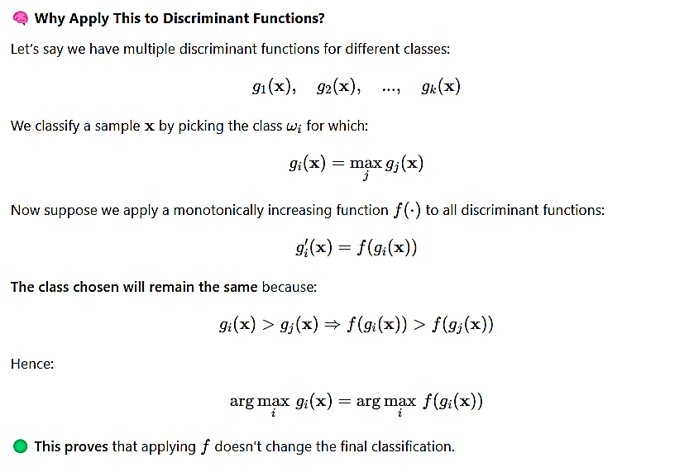

**🔶 7. Explain the structure and function of a general statistical pattern classifier. Use a diagram and discuss the flow from input vector to final class decision.**

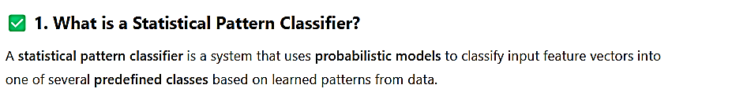

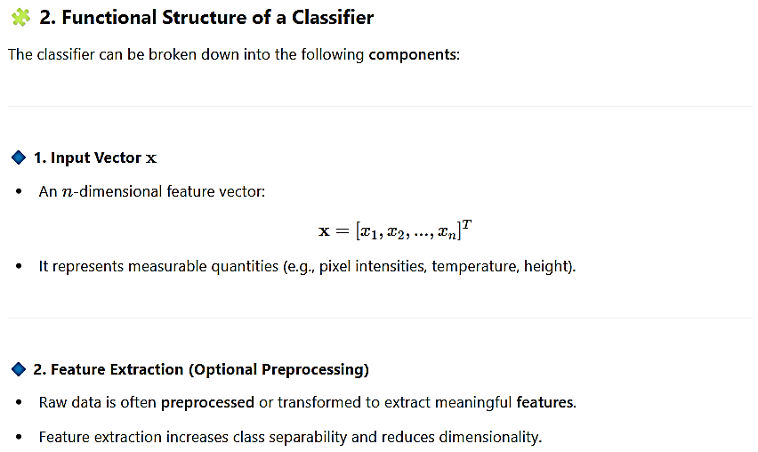



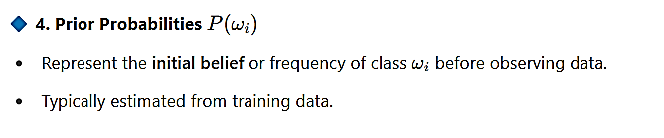



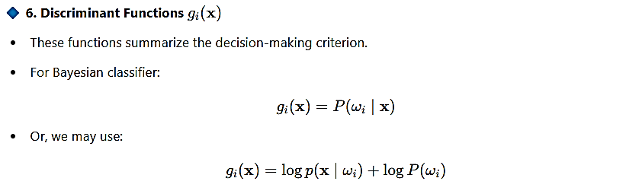



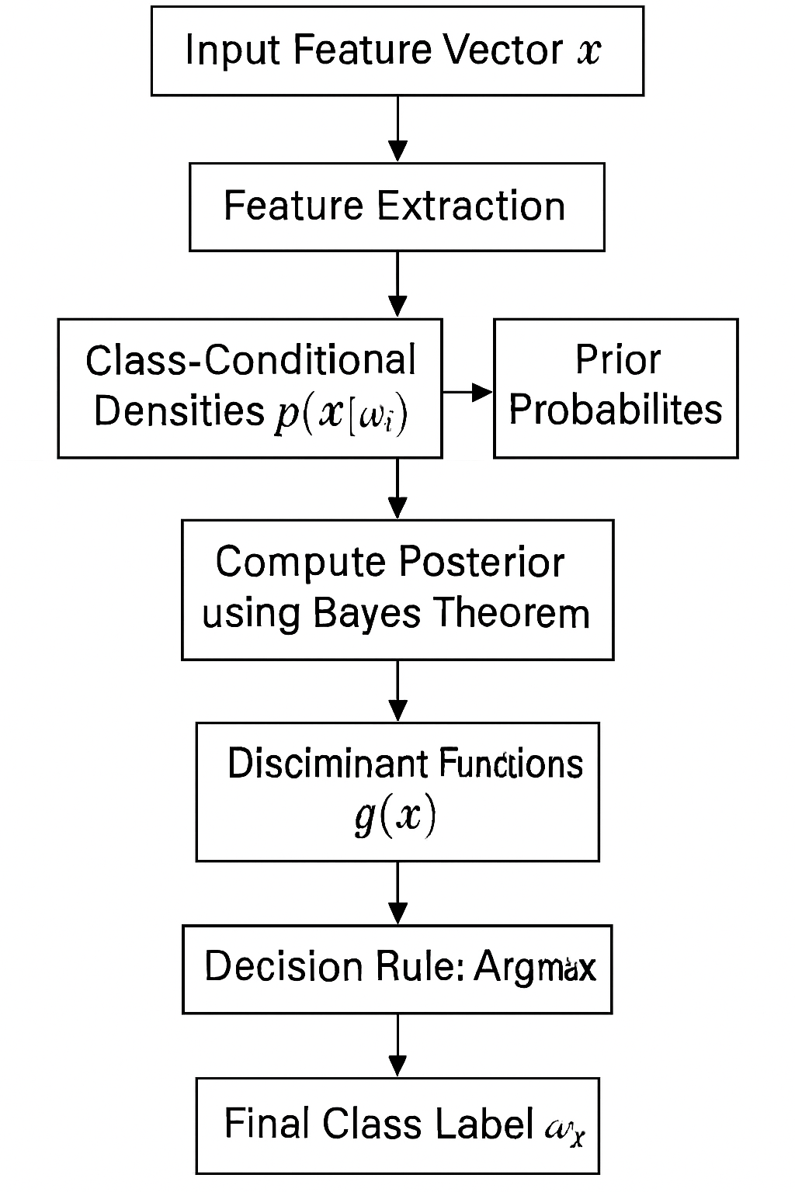

**🔶 Minimum Risk vs Minimum Error Rate Classification**



